“And the peace of God, which surpasses all comprehension, will guard your hearts and your minds in Christ Jesus.” -- Philippians 4:7
- Please show all your work! No partial credit will be given for incorrect answers with no work shown. Please draw a box around your final answer.
- Calculators are permitted, but no notes, text, laptops, PDAs, or electronic dictionaries.
- Cell phones should be muted and left in your pocket or bag.
Total marks: 70

- 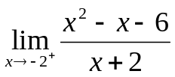 [2]
-5
- 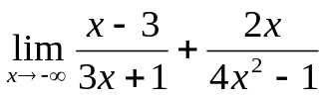 [2]
3
- 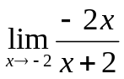 [2]
Does not exist
- 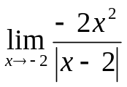 [2]
-2
- Solve: 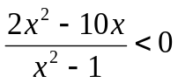 [3]
(-1, 0), (1, 5)
or: -1 < x < 0 and 1 < x < 5
- Solve: (x+2)x²(x-1)(x-2) > 0 [3]
(-2, 1) and (2, ∞)
or: -2 < x < 1 and x > 2
- Let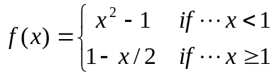.
  - 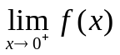 [2]
-1
  - 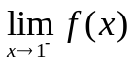 [2]
0
  - Is f(x) continuous at x=0? [2]
No
  - Find the line tangent to f(x)
at x = –1 [3]
y = -2x – 2
- Find (simplify): 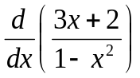 [4]
(3x² + 4x + 3) / (1 – x²)²
- Find (simplify): 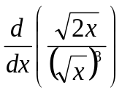 [4]
-(√2) / x²
- Let 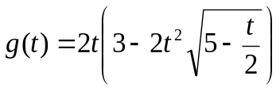.
Find 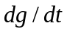 (no need to simplify). [4]
2( 3 – 2t² √(5 – t/2) ) –
2t( 4t √(5 – t/2) + t² (5 – t/2)^{-1/2} (-½)

- Find the equation of the line tangent to the curve 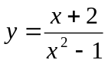 at the point (0, -2). [4]
dy/dx = (– x² – 4x – 1) / (x² – 1)²
= -1 @ x=0
y = –x – 2
- The position in metres of a particle in a certain changing magnetic field is 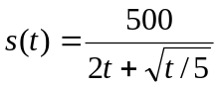, where t is time in seconds. What is the velocity (rate of change) of the particle at t=5 seconds? (Calculator approximation okay.) [4]
ds/dt = -500 (2t + √(t/5))⁻² (2 + 1/(2√(5t)))
≈ 8.678 m/s
@ t=5
- If 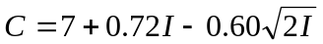 describes total consumption as a function of income, find the marginal propensity to save when the income is 8. [3]
dC/dI = 0.72 – 0.60/√(2I) = 0.57, so marginal propensity to save is 0.43
- Find the marginal-cost function if the average cost per unit is 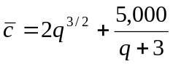. [3]
c = 2q^{5/2} + 5000q / (q+3)
dc/dq = 5q^{3/2} + 15000 / (q+3)²
- The demand curve for a certain product is modeled as: 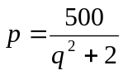, where p is price in dollars and q is thousands of units demanded.
  - What happens as 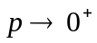? Interpret this in the context of customer demand. [3]
q goes to infinity: infinite demand for a free product
  - What happens as 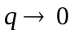? Interpret this in the context of customer demand. [3]
p(0) = $250: at this price nobody will buy the product
  - How many units are demanded when the price is $100? [2]
√3 ≈ 1.732 thousand
  - Write an expression for revenue as a function of quantity demanded. [2]
r = pq = 500q / (q² + 2)
  - Say the current demand is for 4 thousand units. What is the rate of change of the revenue with respect to quantity demanded? [4]
dr/dq = –500 (q² – 2) / (q² + 2)²
@q=4: dr/dq = -21.6
($ per thousand units)
  - If there are m employees, they can produce 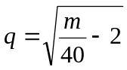 (thousand) units per day. How many employees are needed to meet the demand of 4 thousand units? [3]
720
  - Calculate the marginal-revenue product at the current demand of 4 thousand units. Give an exact answer. [4]
dq/dm = (1/80) (m/40 – 2)^{-1/2}
@m=720: dq/dm = 1/320
dr/dm = (dr/dq)(dq/dm) = (-21.6)(1/320) = -0.0675 ($ per employee)

